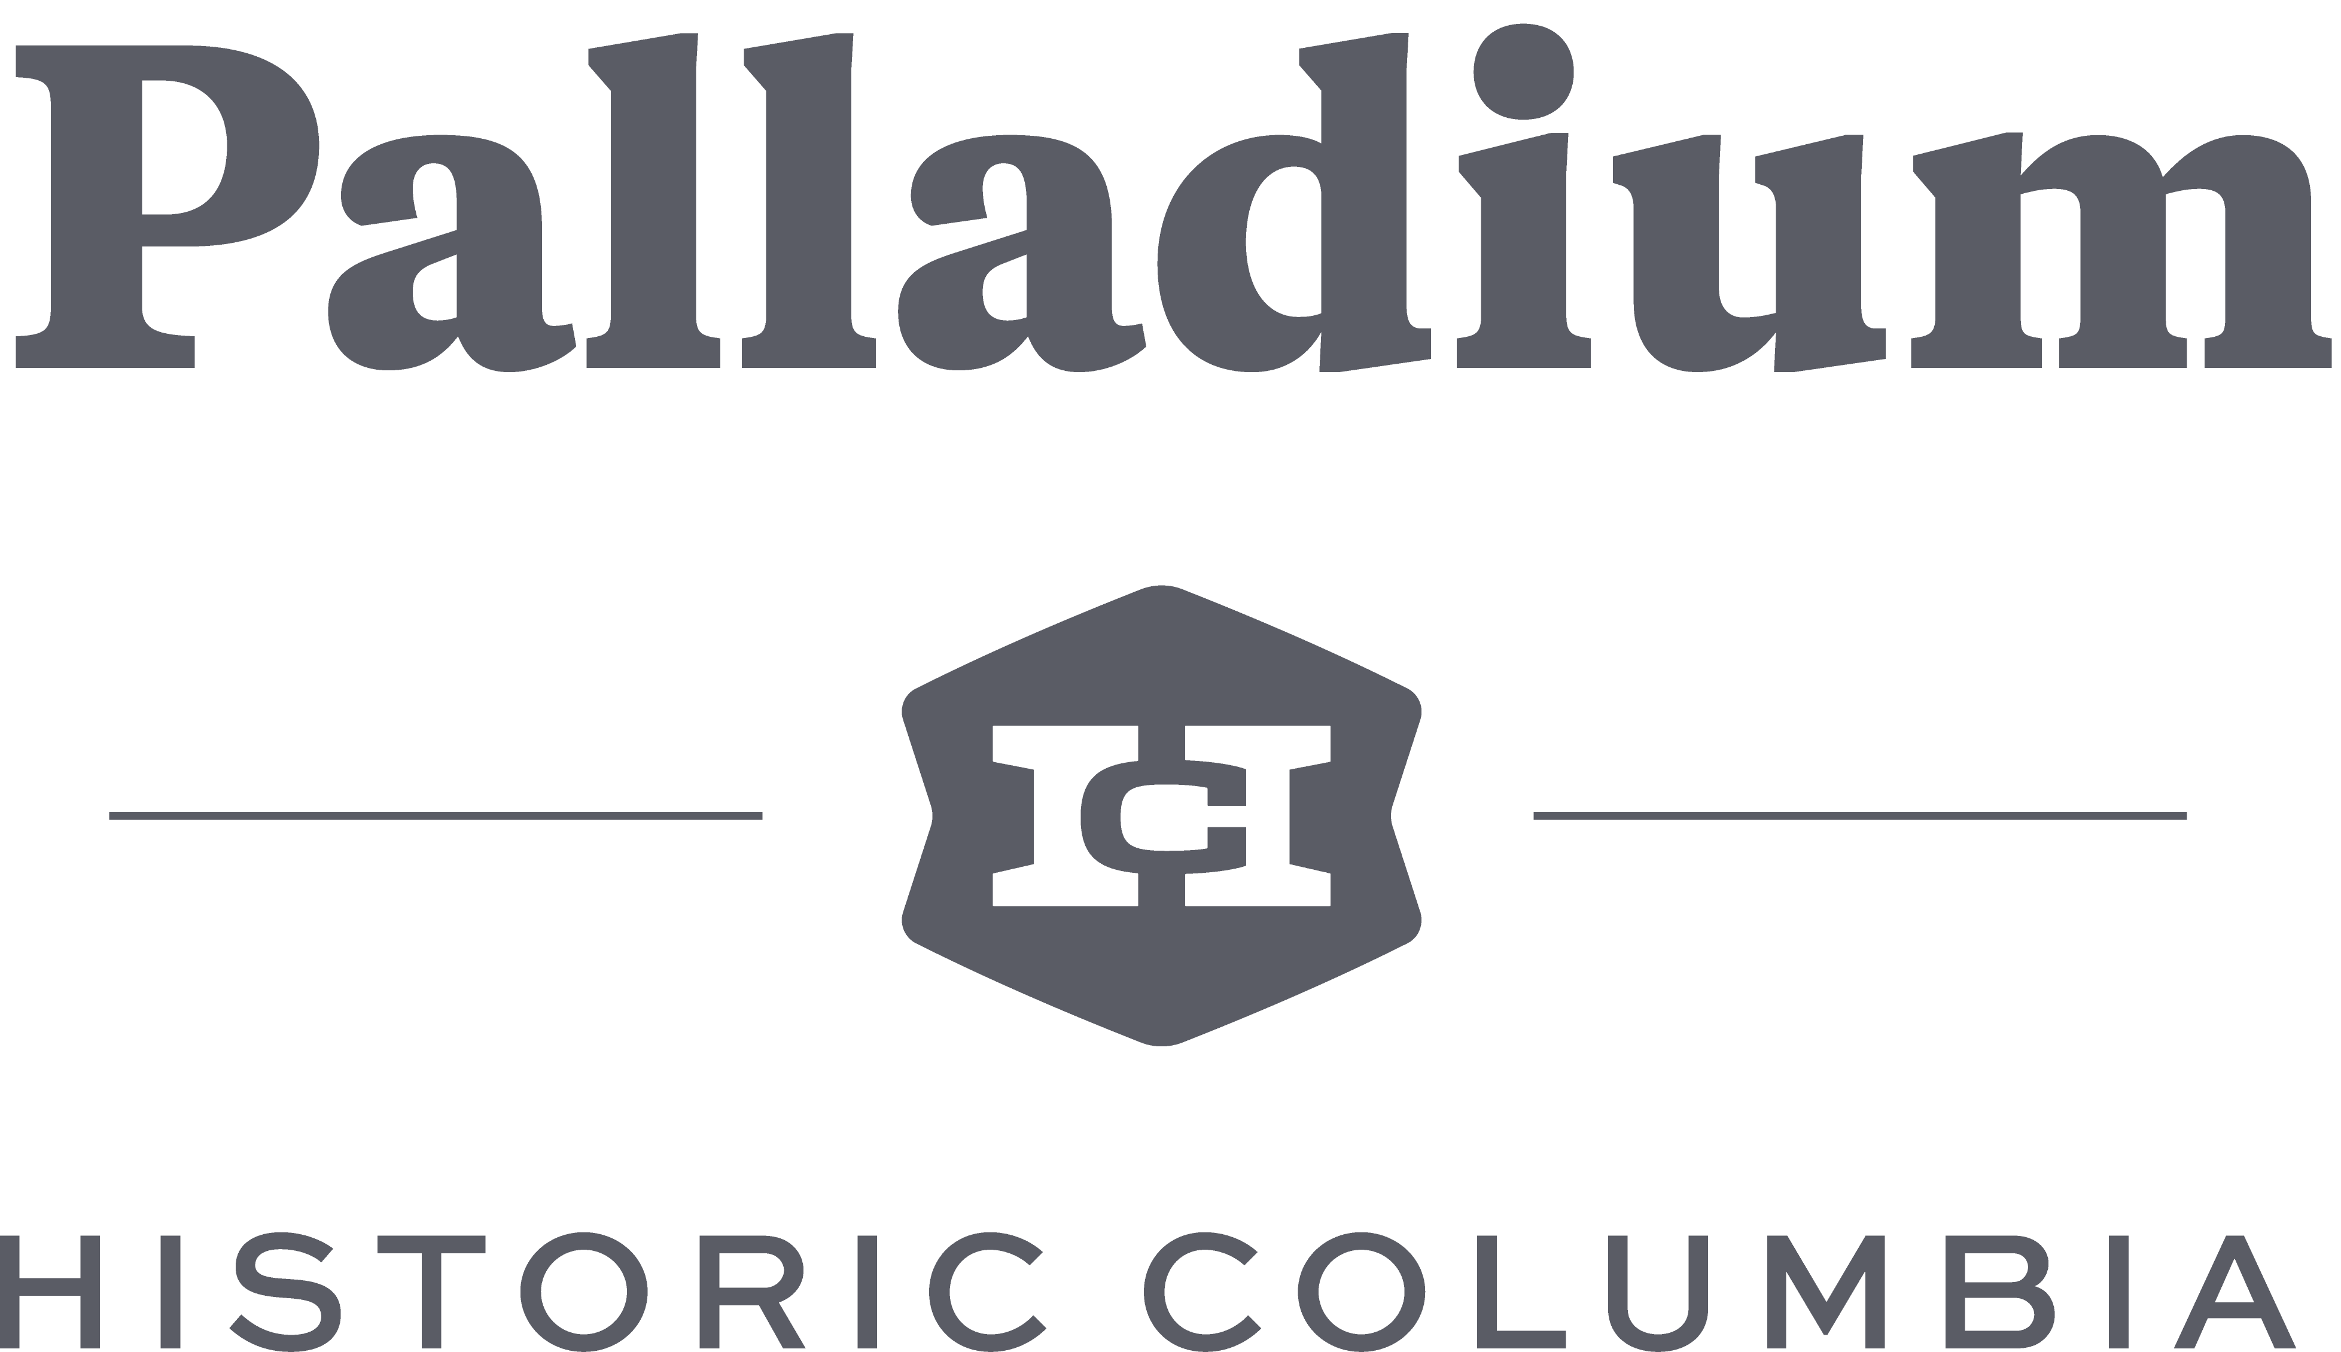

2018 Palladium Fall Tour Sponsorship Opportunities

Palladium is a dynamic organization of professionals who support the mission of Historic Columbia through educational, social and fundraising initiatives. Since its inception more than 15 years ago, this group of leaders has become a strong fundraising force for Historic Columbia. Palladium’s two largest events, combined with social and membership cultivation events, attract more than 1,250 professional attendees each year and raise over $25,000 to support the mission of Historic Columbia.
SPECIAL EVENT DETAILS
Palladium Fall Tour: Stayin’ Alive on Main Street
This inaugural event will be held on Columbia’s Main Street over two days in November 2018.

Friday, November 2, 7-10 pm:
On the evening of November 2, Palladium will host a 1970’s themed party at the historic Arcade Mall (1332 Main Street). This event will include specialty food and drinks, music and dancing. Guests will also have an opportunity to take a tour of the Down Under area below the Arcade. Costumes encouraged! Tickets purchased for Friday night include a ticket for Saturday.

Saturday, November 3, Noon- 5pm:
On Saturday, November 3, Palladium will host a tour of loft spaces on Main Street, starting and ending at a beer garden at The Venue on Main. Tickets include a map of the locations available to tour, access to the beer garden, and one beer ticket. Beers will be available for purchase by The Whig.

CONTACT

Megan Plott, Director of Development
Phone: 803.252.7742 x 12
Fax: 803.929.7695
Email: mplott@historiccolumbia.org

$1500 FALL TOUR GOLD SPONSORSHIP LEVEL
- Fall Tour event benefits
  - Primary business logo on print and digital collateral (examples include postcard, posters, sponsor boards, slideshows and table signage displayed throughout events)
  - One social post with logo displayed on Facebook (16,300+ followers), Instagram (8,800+ followers) & Twitter (12,600+ followers) for Fall Tour
  - Recognition of sponsorship in two e-newsletters (8,000+ recipients)
  - Recognition of sponsorship on event page on historiccolumbia.org (average 30,000 views/month)
  - Reserved sponsor table, which can be used for advertisement and distribution of promotional information to attendees at Fall Tour
  - Verbal sponsor recognition from entertainment stages throughout Fall Tour
  - Complimentary tickets to Fall Tour
    - 4 weekend passes to Fall Tour ($400 value)
  - Additional tickets available for purchase at the Palladium member price for up to 10 sponsor guests for Fall Tour
- Donor listing on the corporate donor page on historiccolumbia.org during 2018-19

$750 FALL TOUR SILVER SPONSORSHIP LEVEL
- Special Event Benefits
  - Secondary business logo on print/digital materials (examples include postcard, posters, sponsor boards, slideshows and table signage displayed throughout events)
  - One post with logo displayed on Facebook (16,300+ followers), Instagram (8,800+ followers) & Twitter (12,600+ followers) for Fall Tour
  - Recognition of sponsorship on event page on historiccolumbia.org (average 30,000 views/month)
  - Reserved sponsor information table which can be used for advertisement and distribution of promotional information to attendees for Fall Tour
  - Verbal sponsor recognition from entertainment stages throughout Fall Tour
  - Complimentary tickets to Fall Tour
    - 2 weekend passes to Fall Tour ($200 value)
- Donor listing on the corporate support page of historiccolumbia.org

$500 FALL TOUR BRONZE SPONSORSHIP LEVEL
- Special Event Benefits
  - Business name only on print/digital materials (examples include postcard, posters, sponsor boards, slideshows and table signage displayed throughout events)
  - One post with name displayed on Facebook (16,300+ followers), Instagram (8,800+ followers) & Twitter (12,600+ followers) for Fall Tour
  - Recognition of sponsorship on event page on historiccolumbia.org (average 30,000 views/month)
  - Verbal sponsor recognition from entertainment stages throughout Fall Tour
  - Complimentary tickets to Fall Tour
    - 2 weekend passes to Fall Tour ($200 value)
- Donor listing on the corporate support page of historiccolumbia.org

Are you interested in a yearlong sponsorship for both the Palladium Fall Tour on November 2-3, 2018 and the silent auction on March 21, 2019? Yearlong event sponsor opportunities are available at $2,500 and $1250. Contact Megan Plott at 803.252.7742 x12 or mplott@historiccolumbia.org for detailed benefits and availability.

2018 Fall Tour Sponsor Form

Name_________________________________________________________________________
(As you would like it to appear in programs and publications)

Contact Name__________________________________________________________________

Address_______________________________________________________________________

City, State, Zip__________________________________________________________________

Phone_______________________________ Email_____________________________________

SPONSOR LEVEL:

- $1,500 2018 Palladium Fall Tour Gold Sponsor*
- $750 2018 Palladium Fall Tour Silver Sponsor*
- $500 2018 Palladium Fall Tour Bronze Sponsor

*Please note: HC must receive sponsor form and artwork prior to October 1, 2018 for complete marketing recognition in the Fall Tour promotional material.

PAYMENT:

- Invoice in October 2018
- Check made payable to Historic Columbia is enclosed
- Credit Card Payment

Name on Card__________________________________________________________________

Account Number __________________________________Expiration Date_____ CVC # ______

Signature______________________________________________________________________

PLEASE RETURN THIS FORM TO:
Megan Plott, Director of Development
Fax: 803.929.7695 | email: mplott@historiccolumbia.org
Thank you for your support!

