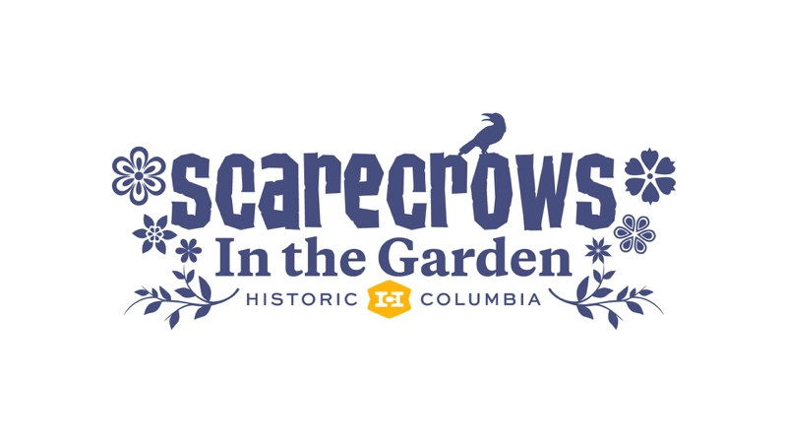
Registration Form

Contact Name

Organization / Business / Artist / Family / Class Name
(This will appear on your scarecrow ID)

Name of Scarecrow
(This will appear on your scarecrow ID)

Address

City State Zip

( )
Telephone Email

Please submitted entry forms by Friday, September 27th

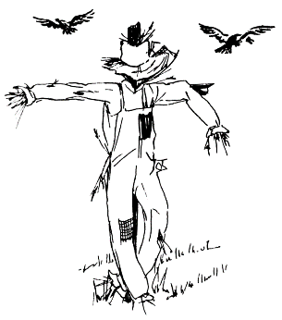
Mail to:
Historic Columbia
Scarecrows in the Garden
1601 Richland Street
Columbia, SC 29201

Bring to:
Gift Shop at the Robert Mill House
1616 Blanding Street

Email to:
reservations@historiccolumbia.org

Key Dates
September 28-30 Scarecrow Set Up
Please plan to set up your scarecrows on the grounds of the Robert Mills House and Gardens between 1:00pm and 4:00pm. Check in at the Gift Shop. If you need a different time, please call 252-1770 x 23 to schedule an appointment.
October 1-31 Scarecrows in the Garden Exhibit
Scarecrows will be on display Monday-Saturday from 10:00-4:00 and Sunday from 1:00-5:00.
November 1– 3 Scarecrow Pick-Up
Scarecrows not picked up by 4:00pm on Saturday, November 2nd will be discarded. Please consider pick up a “salvage opportunity”. (Please do not pick up scarecrows prior to October 31st.)

Guidelines & Entry Rules
- Entry this year is FREE! Families, community groups, businesses, museums, schools, and individuals are all welcome to participate in this month-long event.
- Entries must be three-dimensional.
- Entries cannot be made of paper or contain live plant material (ex: pumpkins, potted plants, vines, etc.)
- Bases must be able to support the scarecrow in a freestanding/staked manner—shepherd’s hooks and PVC pipes are permissible.
- Historic Columbia will provide signage identifying you or your organization and the name of your scarecrow.
- You must install your own scarecrow using the designated spots that have been pre-staked with one piece of rebar. If your scarecrow setup requires more than one piece of rebar, please let us know by calling 252-1770 x 23 or emailing reservations@historiccolumbia.org.
- Scarecrows in the Garden is a Family Event, so entries must be suitable for viewing by small children. Entries reflecting controversial political or social subject matter, or in poor taste for family viewing, will not be accepted.
- Historic Columbia reserves the right to use photographs, contact names, and scarecrow names for publicity purposes.
- Historic Columbia reserves the right to remove any scarecrow that deteriorates to an unacceptable level during the display period. Please make your submissions as weather-proof and as indestructible as possible.
- Historic Columbia is not responsible for loss or damage to scarecrows.
- Scarecrows must be picked up by 4pm on November 2nd. Please do not pick up scarecrows prior to Oct. 31st.

